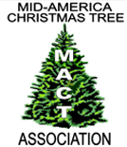

MID-AMERICA CHRISTMAS TREE ASSOCIATION NEWSLETTER

Fall 2020 Donna Cackler, Executive Administrator
midamericachristmastreeassoc@gmail.com
www.midamericachristmastree.com
740-815-6107

News from the MACT –

The Mid-America Christmas Tree Association (MACT) summer meeting for 2020 like so many others was postponed until July 23rd & 24th, 2021.
We are still going to Indiana and will be hosted by Dull’s Tree Farm in Thornton, Indiana. I visited their farm at the end of August and look forward to the meeting there.
This has been a year like no other where so many meetings have been cancelled or held virtually. It has been hard not to see our vendors and they have felt the impact too. Not to mention the social connection and learning from one another that is such a big part of our meetings.
MACT board member Joe Evans is still recovering from Covid-19. He went in the hospital in early June and finally came off oxygen in mid-September. We are so thankful he is doing well and look forward to seeing him next summer.
As we look ahead to our upcoming season, each state has its own set of requirements/restrictions that we all must comply with to ensure the safety of our own staff as well as our customers. This has come with its own set of challenges.
As Christmas tree growers it is our desire, to give our customers a normal Christmas. We need to allow our customers to come out and enjoy our farms, wreaths, and tree fields. We can be part of the solution to giving people a very Merry Christmas.

In other news -
The Ohio Christmas Tree Association worked with Tommy Wagoner of Fraser Knoll to see if they got enough orders would he come to Ohio and deliver their supplies. They did and he arrived with his 20- foot trailer full much to the delight of many Ohio growers.
Wisconsin’s meeting was cancelled as well but they were able to hold a one-day vendor show.
Catherine Howard Meacham of Christmas Trees Magazine is retiring after thirty years at the end of 2020. The magazine is for sale and we hope that this popular magazine continues to inform and educate us for many decades to yet to come.

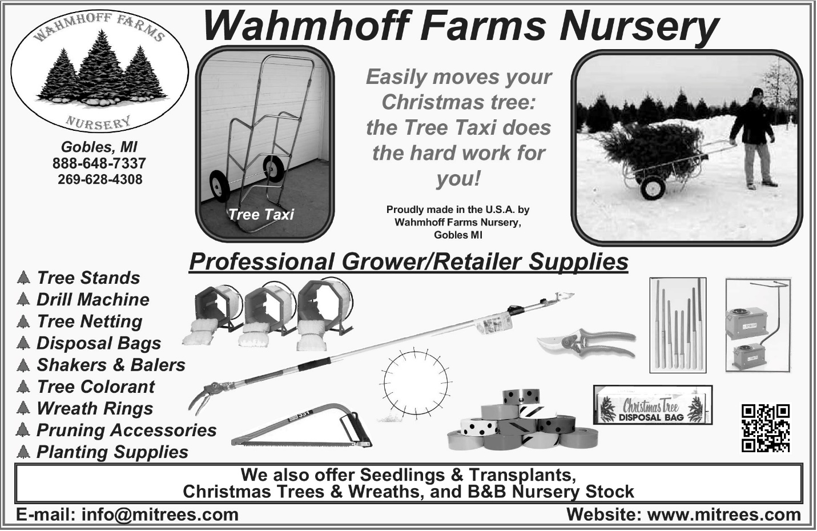

From the Desk of the President…...

Our summer meeting has been rescheduled at Dull’s Tree Farm for next July. I personally am looking forward to seeing everyone again.
As we are all preparing for our Christmas tree season, we face challenges in doing what we love more than ever. Christmas will have a greater significance for many this year to return to the normalcy with having a family-oriented holiday experience.
Each state is dealing with it differently, but I am thankful we can still be a part of family’s holiday tradition of shopping for a Christmas tree.
I pray that everyone will stay safe and healthy and that our country can bounce back from this virus quickly. I pray that God will put his healing hand on all those being affected.
Thanks,
Bill Holesinger

WE’RE LOOKING FOR -
AN EXECUTIVE ADMINISTRATOR
The MACT Board will be seeking candidates for the position of Executive Administrator. Donna Cackler, who has been our Executive Administrator since 2016 wants to retire in 2021!
Our goal is to find our next Executive Administrator so there is ample time to train the new person to have a smooth transition.
Duties include managing the membership, producing the newsletter (2 issues/year), and coordinating all aspects of the summer meeting.
Please contact Donna Cackler to learn more.
midamericachristmastreeassoc@gmail. com or call 740-815-6107
2020-2021 MEMBERSHIP LIST
The membership list is published on our website
www.midamericachristmastree.com

QUESTIONS?
Please contact Donna Cackler, Executive Administrator
740-815-6107
midamericachristmastreeassoc@gmail.com

Mid-America Christmas Tree Association
2020-21 Officers and Directors
Officers (3-year terms [no more than 2 successive terms]

President Vice-President Secretary/Treasurer
Bill Holesinger - 22 [3] Dennis Duke – 22 [3] Joe Eise – 21 [reappoint 21]
7250 Garden Plain Rd. 8023 Mt. Zion Church Rd. 25882 S. Lohman Rd.
Fulton, IL 61252 Philpot, KY 42366 Wright City, MO 63390
309-887-4892 270-281-5555 636-745-7488
jeise1@hotmail.com

Executive Administrator

Donna Cackler [appointed 04/01/16]
5025 Cackler Rd.
Delaware, OH 43015
740-815-6107
midamericachristmastreeassoc@gmail.com

Board of Directors* (3-year term)

Bill Cackler -22[3] Scott Heeren – 22 [1] Joe Evans – 22 [2]
5025 Cackler Rd. 5715 N 750 E 1538 N CR400 W
Delaware, OH 43015 Hamlet, IN 46532 Danville, IN 46122
740-524-5311 574-540-1869 (cell) 317-797-3266 (cell)
cacklerfarms@gmail.com sbheeren@gmail.com ewpfarms@aol.com

Jeff Koning – 18 (21) [1] Jerry Peterson – 21 [2]
P.O. Box 283 873 26th St.
Bloomingdale, IN 47832 Allegan, MI 49010
765-592-6693 269-673-2440
jeffk55@msn.com info@petersons-riverview.com

*Year in parentheses indicates the end of term.
*Number in bracket is number of terms.

MACT T-SHIRTS
ARE NOW AVAILABLE
Please visit the MACT website “member” tab for more information!!

Factors Affecting Planting Stock Availability

For decades, seedling nurseries have produced planting stock based on market
speculation. In the last five or six years, marketing of these plants has shifted dramatically to satisfy standing orders and preorders. This has led to many growers being unable to find planting stock in the ages and varieties they are looking for, especially if they wait to place their orders for the upcoming planting season until later in the year. Besides this timing issue of when an order is placed, nurseries are limited in how many plants they can produce by a variety of factors. These factors include available land, labor, and the size of their facilities to handle the process of digging, grading, and storing plants prior to shipment.
Land used for nursery production is unique. It needs to be well-drained, relatively flat, and in close proximity to the packing and storage facilities of the nursery. This often limits a nursery’s ability to expand production because the right piece of land is simply not available. Tying into this factor of land is also the issue of an available water source for irrigation. The land needs either to be close to a surface water source or have the capacity to produce a large volume of water through a well.
Regardless of how many plants a nursery produces, it takes an increase in short term labor to get the work done. Some nurseries accomplish this with contracted H-2A workers, some use high school students after school, and others fill this need with seasonal local workers. As the years go on, it seems to be getting more difficult to find workers willing to do the work, no matter the source used to fill the positions.
The other limiting factor in nursery production is the size of the packing and cold storage facility on site. Nurseries have a brief 4 to 6-week window in the spring to harvest, grade, package, and ship hundreds of thousands if not millions of plants. This is truly a hectic time of year. A nursery needs to have a large enough facility to handle the amount of plants it is producing.
Many growers call looking for planting stock and are surprised to find limited or no plants available after contacting several nurseries. The question that is often asked is “are growers increasing the number of trees they are planting?” My opinion is that is not the case. I think there are fewer nurseries producing planting stock for the Christmas tree industry, and those nurseries are operating at peak production. My advice to growers is to find a nursery that they are comfortable working with, develop a long-term relationship with them, and put in a standing order for difficult to find species such as Fraser Fir and Canaan Fir. This will help to guarantee that your farm will have the plants necessary to keep production consistent for the future.

Submitted by Jerry Peterson, Peterson’s Riverview Nursery
The years 2020 is a crazy one for sure, Riots, Protests and CORONA Virus. When I think of Corona a happier definition comes to mind than the current pandemic. We think of the Spanish word for Wreaths, “Corona.” This Christmas season is bound to be full of new challenges and struggles. Will our gift shop open, will customers come out, how will I protect my customers and workers? One thing is for sure and can never be cancelled, that is “Christmas.” We must not give into fear this Christmas season.

Our Christmas Trees, Wreaths and Garlands may be the only sense of normal our customers may have had all year. We cannot take that away from them. As Christmas tree growers it is our duty, to give our customers a normal Christmas. We need to let our customer come out and enjoy our farms, wreaths, and tree fields. Christmas tree farms have the cleanest air you can breathe anywhere. What better place to do your Christmas shopping than in the fresh air of a Christmas Tree farm?

Instead of spreading fear we need to welcome people to our farms and tree lots. Let our customers know that we are the safest place to do their Christmas shopping. This year could be one for the record books if we do it right. As Christmas tree growers we can be part of the solution to giving people a very Merry Christmas.

What I hope to see for popular trends this Christmas season is people coming to the tree farm with their family and enjoying what really matters. It is our goal to have our customers to have an Old-Fashioned Christmas. We want to offer our best wreaths, trees, and garlands for them.
I feel it is very important to make our customers feel welcome and comfortable. We should offer hand sanitizer, masks, and lots of fresh air. It is also very important that we do not scare away or chastise our customers who do not use masks. Remember we are Christmas tree farmers not the police or the health department.

In our business we have seen a growing trend this season. Companies that make wreaths and garland are going out of business or downsizing every day. This in turn leads to many tree farms buying their own wreath and garland machines when they no longer have to rely on outside sources for their wreaths and garland.

We cannot say for sure how the 2020 tree and wreath season will be. Together we can all do our part to make this the best Christmas yet for our customers.

Submitted by Chris Schultz, Northwood Evergreens

REFLECTIONS ON 2020
2020 has been a year to forget, but hopefully the 2020 Christmas season will be one to remember. Most all the growers that I have talked to believe that this Christmas season will be one of the best they will have ever had. Families have a new bond since they have been together due to COVID. Most of them will not be traveling and will want to have a memorable family Christmas. They are doing more things together and that includes going to find a Christmas tree, wreaths or whatever they want to decorate with. They enjoy the family outings more. This has been normal in the past after a disaster. According to the recent survey by the Christmas Tree Promotion Board, consumers want Christmas to be more special than normal and they want it to be memorable. We need to reinforce to customers that getting a real tree is an experience, rather than just a product. The excitement of the family going to buy a tree can be reinforced by the grower/retailer making it an experience. That experience can be enhanced by the activities of agritainment, having Santa in the trees, smells of hot chocolate and apple cider doughnuts or just having a festive spirit. Make the customer feel good for bringing the family out to enjoy the purchase of buying a tree.
As far as the supplies and equipment side of the business, customers seem to be buying earlier and earlier each year. I am of the belief that this is due to the shortage of Christmas trees in the US over the last few years. People get a mindset that if there is a shortage of trees that we need to get our supplies before they run out. There are not many new items out this year. There are always improvements that are made to products and someone will always come out with a better mousetrap! But most people just want the tried and true supplies. At Fraser Knoll we always try to have all the items that a customer will need. We do our best to always have them available, but each year it is a challenge to know exactly how many of each item we need to have in stock! We will do our best to have them and get them to you when you want them.
It has been a sad year for us at Fraser Knoll. The last half of the founders of Fraser Knoll passed away late this summer. Dot Wagoner had lived a great 96 years. She said that living to be 100 is not all that it is cracked up to be! Fred Wagoner passed away nine years earlier. They are now both looking down on all of us and wishing their guidance to all growers and retailers.

Submitted by Tommy Wagoner

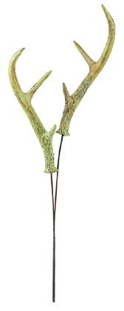
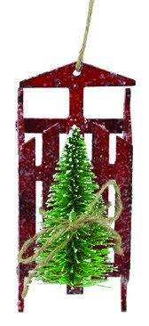
Christmas Ribbon • Wreath Rings
Pine Cones • Wreath Decorations
Glue & Glue Guns
Santa’s Wholesale Supply
RIBBON
SAMPLES
UPON
REQUEST
Santa’s Own
“ELF DC”
GARLAND
MACHINE
Stainless
Steel
BEST SERVICE AT LOWEST PRICES
Same Day Shipping!
Free Catalog
VISIT US AT

www.santasupplies.com
CALL US AT

1-800-772-6827
EMAIL

santa@santasupplies.com
IT MAY NOT BE CHRISTMAS-AS-USUAL, but it could be even better…
COVID-19 has changed nearly every aspect of our lives … but as Christmas tree growers we are optimistic. Families everywhere struggle to provide a balance for their children. Selecting a Christmas tree may offset the disruption of normalcy from COVID-19 with a family-oriented experience. Going out to pick a tree is an experience family can look forward to and it will help create better memories to close out what has been an incredibly challenging year.
There will be changes as to how you operate this season. The one thing COVID will not change is the joy that Christmas brings.

A LITTLE HISTORY
MACT SUMMER SHOW LOCATIONS
YEAR | FARM NAME | OWNER NAME | STATE
1987 | Mule Tree Farm | Jewell & Peggy Province | Missouri
1988 | Strautman’s Tree Farm | Jim Strautman | Iowa
1989 |  | Jerry Mills | Illinois
1990 | 4 E’s Trees | Frank Evans | Illinois
1991 | Eby’s Pine |  | Indiana
1992 | Pumpkin & Pines | Jim & Karen Marschel | Missouri
1993 | Murphy’s Christmas Trees | Jim Murphy | Iowa
1994 |  | Jerry Mills | Illinois
1995 | Kingma Christmas Tree Farm | Harold Kingma | Indiana
1996 | Miller’s Green Tree Farm | Crow & Joyce Miller | Illinois
1997 | Mule Tree Farm | Jewell & Peggy Province | Missouri
1998 |  | Carl & Dorothy Young | Ohio
1999 | Eby’s Pine |  | Indiana
2000 | Grady’s Christmas Tree Farm | Robert & Emily Grady | Illinois
2001 | Meert Tree Farm | D. Meert | Missouri
2002 | Captain Jack Tree Farm |  | Iowa
2003 | Big Tree Plantation |  | Ohio
2004 | Kingma Christmas Tree Farm | Harold Kingma | Indiana
2005 | Alfeldt Brothers Farm LLC | Cecil Alfeldt | Illinois
2006 | Santa’s Forest | Schmitt Brothers | Missouri
2007 | Bohman’s Tree Farm | Mike & Sandy Bohman | Indiana
2008 | Daniken Tree Farm | David & Joey Daniken | Illinois
2009 | Heritage Valley Tree Farm | Virgil & Bea Spaunhorst | Missouri
2010 | Wahmhoff Tree Farm | Dan Wahmhoff | Michigan
2011 | Wapsie Pine Tree Farm |  | Iowa
2012 | Timbuk Farms |  | Ohio
2013 | Hensler’s | John Hensler | Indiana
2014 | Peterson’s Riverview Nursery | Jerry Peterson | Michigan
2015 | Richardson’s Adventure Farm | Robert/George Richardson | Illinois
2016 | Pea Ridge Forest | Leroy Rood | Missouri
2017 | Pine Tree Barn | Roger Dush | Ohio
2018 | Tannenbaum Farms & Peacock Rd | Mel Koelling/Ed Carpenter | Michigan
2019 | Country Side Trees | Glen & Becky Feltham | Wisconsin
2020 | MEETING POSTPONED – COVID 19
We have had a meeting every year since 1987 except 2020. Our hosts have been Illinois (8), Indiana (6), Iowa (4), Michigan (3), Missouri (7), Ohio (4) and Wisconsin (1).
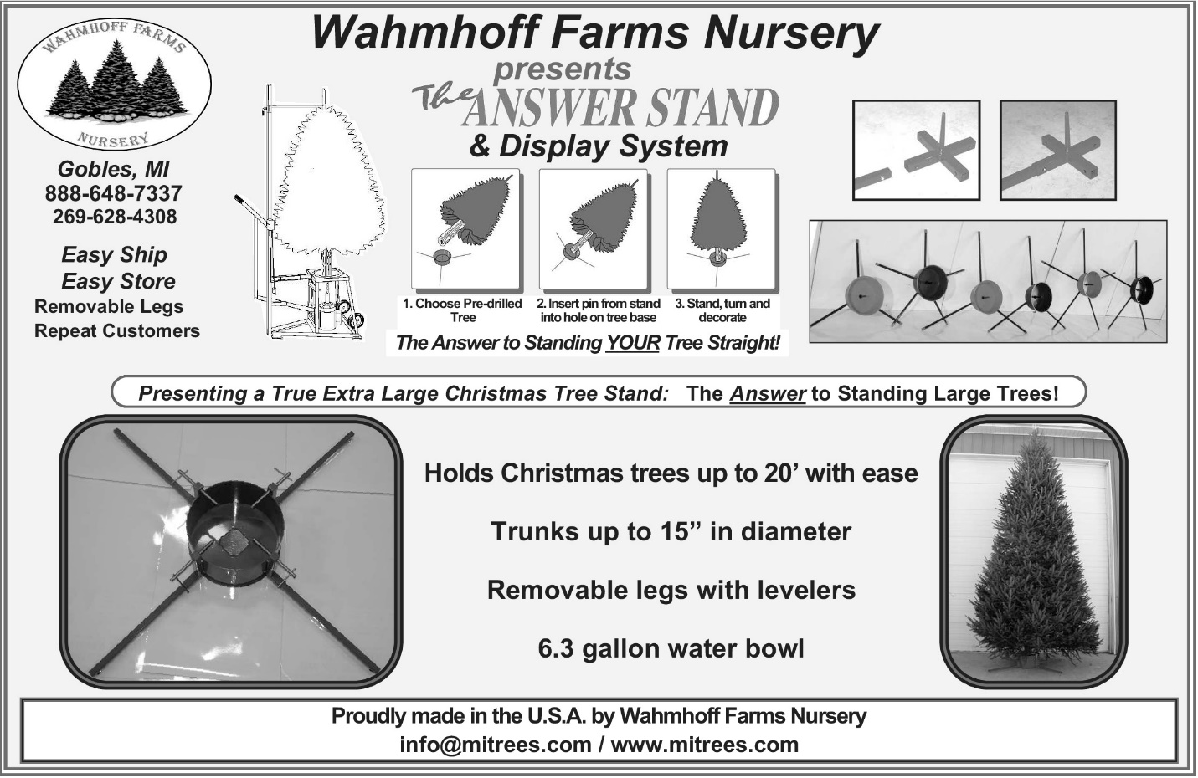

MACT
c/o Donna Cackler
5025 Cackler Rd.
Delaware, OH 43015

